**THADOMAL SHAHANI ENGINEERING COLLEGE**

**DEPARTMENT OF INFORMATION TECHNOLOGY**

**MINI – PROJECT Report on**

**MUMBAI FESTIVALS**

Submitted in partial fulfilment of the requirements

Of the degree of

**THIRD YEAR OF ENGINEERING**

in the subject

**INTERNET PROGRAMMING**

**by**

01 Komal Ajay Aswani

20 Mahima Ajay Gupta

21 Hiba Altaf Hussain

________________________

Teacher-incharge

2018-19

**TABLE OF CONTENTS**

**Chapter Page No.**

**1. Introduction**

1.1 Problem Statement

1.2 Requirements

1.3 Scope

**2. Requirement Analysis**

**3. Description**

3.1 Client side

3.2 Server side

3.3 Database

**4. Hardware and Software Requirements**

**5. Snapshots of Website**

**References**

**Acknowledgement**

**LIST OF FIGURES**

**Figure No. Name Page No.**

5.1 Homepage

5.2 Registration form

5.3 Login form

5.4 Main page-1

5.5 Main page-2

5.6 Main page-3

5.7 Main page-4

5.8 Festival 1

5.9 Festival 2

5.10 Booking

5.11 Feedback page

**Chapter 1. INTRODUCTION**

1.1 Problem statement

There are number of festivals that are celebrated in Mumbai throughout the year. The festivals include cultural events, art fest, technical events, theatre shows, music concerts, college events, food festival, religious festival, etc. For every festival that are celebrated in Mumbai the users are allowed to view the description and book the tickets if the seats are available. Proper schedule of the festivals with the reminder of upcoming events are provided for the convenience.

The project is divided into two parts viz Front end and Back end. The content of the web pages are defined using HTThe most interesting new HTML5 elements are:

* New **semantic elements** like <header>, <footer>, <article>, and <section>.
* New **attributes of form elements** like number, date, time, calendar, and range.
* New **graphic elements**: <svg> and <canvas>.
* New **multimedia elements**: <audio> and <video>.
* <header> Element :- The <header> element specifies a header for a document or section. The <header> element should be used as a container for introductory content. You can have several <header> elements in one document.

<footer> Element :- The <footer> element specifies a footer for a document or section. A <footer> element should contain information about its containing element. A footer typically contains the author of the document, copyright information, links to terms of use, contact information, etc. You may have several <footer> elements in one document.ML5. The layout of the web pages are specified using CSS. The behaviour of the web pages are programmed using JavaScript. In order to maintain the records of the users, authentication process is added as a feature in the form of registration and login web pages. The collected data is maintained in mysql using PhyMyAdmin.

The project is the website built using HTML5, CSS, JavaScript and Php mysql.

1.2 Requirements

In order to provide the visitors of the website an easy to use system which will guide them with the illustrative description of the festivals, we have selected the topic of our website as Mumbai Festivals.

1.3 Scope

Our website Mumbai Festivals covers all the popular festivals that are celebrated in Mumbai. In addition to that, the information provided in the website is descriptive that will help people to get details and know more about the festivals in Mumbai. The layout of the website is designed in such a way that the website is easier to use and this will help us to increase the reach of the website.

The feedback of the events is taken from the users based on which the popularity of the festivals are decided and is displayed on the web page. The features are thus added in such a way that it can be easily updated with the response. This will in turn increase the scope of the project.

As a future scope and keeping in the view the further updation to the website, we are trying to include ticket booking system for the festivals which will include the involvement of third party using web services.

**Chapter 2. Requirement Analysis**

Everyone of us are fascinated by the celebrations that take place in Mumbai throughout the year. Many are curious to know more about some festivals which they like and wants to know about the responses of other people. So in order to provide the visitors of the website an easy to use system which will guide them with the illustrative description of the festivals, we have come up with the website named Mumbai Festivals.

After analysing different websites on internet, we found that there is a need of a platform where people living in Mumbai must get to know about the festivals at their own place. In our website, we have made this possible. Even once they are a registered user of the website, they can receive notification about the upcoming festivals so that they will not miss out their favourite festivals.

This is the reason why we have chosen our topic as Mumbai Festivals.

**3. DESCRIPTION**

**3.1 Client Side Technology**

HTML 5

HTML5 is the latest and most enhanced version of HTML. Technically, HTML is not a programming language, but rather a markup language.

HTML5 is a cooperation between the World Wide Web Consortium (W3C) and the Web Hypertext Application Technology Working Group (WHATWG).

HTML5 introduces a number of new elements and attributes that can help you in building modern websites.

The most interesting new HTML5 elements are:

* New **semantic elements** like <header>, <footer>, <article>, and <section>.
* New **attributes of form elements** like number, date, time, calendar, and range.
* New **graphic elements**: <svg> and <canvas>.
* New **multimedia elements**: <audio> and <video>.

In the project, we have used the new input elements on HTML5  such as header, footer, article, aside which gives a proper framework to the web page. We have also used the HTML form which consists of a range of form elements in the registration and the login form. The meta tag provides the metadata of an HTML document and makes it compatible in various devices.

Following are the elements and tags of HTML5 used in our project:

* The <!DOCTYPE> Declaration

The <!DOCTYPE> declaration represents the document type, and helps browsers to display web pages correctly.

* <header> Element

The <header> element specifies a header for a document or section. The <header> element should be used as a container for introductory content. You can have several <header> elements in one document.

* <footer> Element

The <footer> element specifies a footer for a document or section. A <footer> element should contain information about its containing element. A footer typically contains the author of the document, copyright information, links to terms of use, contact information, etc. You may have several <footer> elements in one document.

* HTML Layout Elements :- Websites often display content in multiple columns (like a magazine or newspaper).HTML5 offers new semantic elements that define the different parts of a web page.

|  |  |
| --- | --- |
| HTML5 Semantic Elements   * <header> - Defines a header for a document or a section * <nav> - Defines a container for navigation links * <section> - Defines a section in a document * <article> - Defines an independent self-contained article * <aside> - Defines content aside from the content (like a sidebar) * <footer> - Defines a footer for a document or a section * <details> - Defines additional details * <summary> - Defines a heading for the <details> element |  |

* HTML Video

The HTML5 <video> element specifies a standard way to embed a video in a web page. The controls attribute adds video controls, like play, pause, and volume. It is a good idea to always include width and height attributes. If height and width are not set, the page might flicker while the video loads. The <source> element allows you to specify alternative video files which the browser may choose from. The browser will use the first recognized format. The text between the <video> and </video> tags will only be displayed in browsers that do not support the <video> element.

* HTML Audio

The HTML5 <audio> element specifies a standard way to embed audio in a web page. The controls attribute adds audio controls, like play, pause, and volume. The <source> element allows you to specify alternative audio files which the browser may choose from. The browser will use the first recognized format. The text between the <audio> and </audio> tags will only be displayed in browsers that do not support the <audio> element.

## HTML5 Output Element

## The <output> element represents the result of a calculation (like one performed by a script)

## Example

## <body>

## <header><div class="container">

## <img src="bg1.png"style="width:1250px;height:250px;">

## <div class= "left">

## <form class="example" style="max-width:300px">

## <input type="text" placeholder="Search.." name="search2">

## <button type="submit" >OK</button>

## </form></div></div>

## <div class="navbar">

## <a href="#home">Home</a>

## 

## <div class="dropdown">

## <button class="dropbtn" onclick="myFunction()">Festival Options</button>

## <div class="dropdown-content" id="myDropdown">

## <a href="food.html">Food Festivals</a>

## <a href="theatre.html" target="_blank">Theatre Festivals</a>

## <a href="culture.html">Cultural Festivals</a>

## </div>

## </div>

## <a href="kform.html" >Feedback</a>

## </article>

## <marquee><h3 style="color:orange">*************NSS JOY OF GIVING RECENT EVENT CLICK FOR MORE INFORMATION*******************</marquee>

## </br></br>

## <h2>PAGE INFORMATION</h2>

## <p style="color:#14E6F9; font-family:verdana; font-size:150%; background-color:#08454B;"> Mumbai Fest gives you a platform to explore the various fun and exciting events around the city.Indulge in college, arts, food, theatre and cultural fests. From Concerts to Technical competitions, from theatre arts to delicious food in the city, Mumbai Fest will take you to all.</p>

## </br></br><center><img src="bgiii.png"style="width:900px;height:150px;"></center>

## </br></br><div style="background:color url("div.jpg");"><div class="row">

## <div class="column">

## <img src="ig2.png" style="width:300px;height:300px;">

## <img src="ig3.jpg" style="width:300px;height:370px;">

## </div>

## </div></div>

## <footer style="width:1250px;"><br><br><br>

## <table style="width:100%">

## <tr>

## <th>Related links</th>

## </tr>

## <tr>

## <td>Trivago</td>

## <tr>

## <td>festpav</td>

## </table>

## <h3>Contact Us</h3>

## <center><h3>@Copyrights 2018</h3></center>

## </footer>

## </html>

CSS3

CSS describes how HTML elements are to be displayed on screen, paper, or in other media.

CSS saves a lot of work. It can control the layout of multiple web pages all at once.

CSS can be added to HTML elements in 3 ways:

* **Inline** - by using the style attribute in HTML elements. An inline CSS is used to apply a unique style to a single HTML element.
* **Internal** - by using a <style> element in the <head> section. An internal CSS is used to define a style for a single HTML page.
* **External** - by using an external CSS file. An external style sheet is used to define the style for many HTML pages.With an external style sheet, you can change the look of an entire web site, by changing one file.To use an external style sheet, add a link to it in the <head> section of the HTML page. An external style sheet can be written in any text editor. The file must not contain any HTML code, and must be saved with a .css extension. The most common way to add CSS, is to keep the styles in separate CSS files.

The Following are the features used in our project using CSS3:

## CSS Padding :- The CSS padding property defines a padding (space) between the text and the border.

## CSS Border :- The CSS border property defines a border around an HTML element.

## The id Attribute :-To define a specific style for one special element, add an id attribute to the element.

## E.g. <p id="p01">I am different</p>

## #p01 {     color: blue; }

## The class Attribute :- To define a style for special types of elements, add a class attribute to the element.eg. <p class="error">I am different</p> then define a style for the elements with the specific class.

p.error {  
    color: red;  
 }

In our project, we have used internal and inline CSS3. We have used css3 for slideshows, navigation bar, grid and list format, for social media links, for adding styles to headings, body and paragraphs. Using webkit so that the content alignment remains the same in all browsers.

Example

<style>

body {

background-color:black;

}

h2 {

color:yellow;

background-color:#454E0A;

}

header{

background-color:black;

}

.container{

position:realtive;

}

.left{

position: absolute;

right:70px;

padding-left:20px;

padding-right:20px;

padding-top:10px;}

form.example button {

float:right;

width: 20%;

padding: 3px;

background: blue;

}

.navbar {

overflow: hidden;

background-color: #333;

font-family: Arial, Helvetica, sans-serif;

}

.navbar a:hover, .dropdown:hover .dropbtn, .dropbtn:focus {

background-color: red;

}

.dropdown-content a {

float: none;

color: black;

padding: 12px 16px;

text-decoration: none;

display: block;

text-align: left;

}

.dropdown-content a:hover {

background-color: #ddd;

}

.show {

display: block;

}

.mySlides {display: none;}

img {vertical-align: middle;}

.slideshow-container {

position: relative;

margin: auto;

}

.text {

color:yellow;

font-size: 30px;

padding: 8px 12px;

position: absolute;

bottom: 8px;

right:60px;

text-align: center;

}

.active {

background-color: #717171;

}

/* Fading animation */

.fade {

-webkit-animation-name: fade;

-webkit-animation-duration: 1.5s;

animation-name: fade;

animation-duration: 1.5s;

}

@-webkit-keyframes fade {

from {opacity: .4}

to {opacity: 1}

}

@keyframes fade {

from {opacity: .4}

to {opacity: 1}

}

/* Style the buttons */

.btn {

border: none;

outline: none;

padding: 12px 16px;

background-color: #881409;

cursor: pointer;

}

.btn:hover {

background-color: #CE2919;

}

h2 a{color:white;

text-decoration:none;}

.fa {

padding: 20px;

font-size: 30px;

width: 30px;

text-align: center;

text-decoration: none;

margin: 5px 2px;

border-radius: 50%;

}

.fa:hover {

opacity: 0.7;

}

.fa-facebook {

background: #3B5998;

color: white;

}

table{

text-align:center;

color:yellow;

}

th{

font-size:30;

color:white;}

footer{

background-color:#333;

}

/* Responsive layout - makes the two columns stack on top of each other instead of next to each other */

@media screen and (max-width: 600px) {

.column {

-ms-flex: 100%;

flex: 100%;

max-width: 100%;

}

}

</style>

JAVASCRIPT

JavaScript makes HTML pages more dynamic and interactive. JavaScript is the programming language of HTML and the Web.

Alongside HTML and CSS, JavaScript is one of the three core technologies of the World Wide Web. JavaScript enables interactive web pages and thus is an essential part of web applications. The vast majority of websites use it, and all major web browsers have a dedicated JavaScript engine to execute it.

As a multi-paradigm language, JavaScript supports event-driven, functional, and imperative (including object-oriented and prototype-based) programming styles. It has an API for working with text, arrays, dates, regular expressions, and basic manipulation of the DOM, but the language itself does not include any I/O, such as networking, storage, or graphics facilities, relying for these upon the host environment in which it is embedded.

Initially only implemented client-side in web browsers, JavaScript engines are now embedded in many other types of host software, including server-side in web servers and databases.

In our project, we have used JavaScript for automatic animation of slideshow function after a given amount of time, changing the layout from list to grid and vice versa, down menu, button onclick, select option function.

* The <script> tag is used to define a client-side script (JavaScript).The <script> element either contains scripting statements, or it points to an external script file through the src attribute.Common uses for JavaScript are image manipulation, form validation, and dynamic changes of content.
* To select an HTML element, JavaScript very often uses thedocument.getElementById() method.
* The <noscript> tag is used to provide an alternate content for users that have disabled scripts in their browser or have a browser that doesn't support client-side scripts.

In our project we have used JavaScript for following purpose:

1. For generating drop down menus
2. Transition of images in slideshows
3. On button click displays description
4. For each values of select option a new output is generated
5. On click data changes using innerHTML

Example of our code:

To generate drop down menus

<script>

function myFunction() {

document.getElementById("myDropdown").classList.toggle("show");

}

window.onclick = function(e) {

if (!e.target.matches('.dropbtn')) {

var myDropdown = document.getElementById("myDropdown");

if (myDropdown.classList.contains('show')) {

myDropdown.classList.remove('show');

}

}

}

</script>

To generate transitions of images in slideshows

<script>

var slideIndex = 0;

showSlides();

function showSlides() {

var i;

var slides = document.getElementsByClassName("mySlides");

var dots = document.getElementsByClassName("dot");

for (i = 0; i < slides.length; i++) {

slides[i].style.display = "none";

}

slideIndex++;

if (slideIndex > slides.length) {slideIndex = 1}

for (i = 0; i < dots.length; i++) {

dots[i].className = dots[i].className.replace(" active", "");

}

slides[slideIndex-1].style.display = "block";

dots[slideIndex-1].className += " active";

setTimeout(showSlides, 1500); // Change image every 2 seconds

}

</script>

To generate different views of data

<script>

var elements = document.getElementsByClassName("column");

// Declare a loop variable

var i;

// List View

function listView() {

for (i = 0; i < elements.length; i++) {

elements[i].style.width = "100%";

}

}

// Grid View

function gridView() {

for (i = 0; i < elements.length; i++) {

elements[i].style.width = "30%";

}

}

/* Optional: Add active class to the current button (highlight it) */

var container = document.getElementById("btnContainer");

var btns = container.getElementsByClassName("btn");

for (var i = 0; i < btns.length; i++) {

btns[i].addEventListener("click", function(){

var current = document.getElementsByClassName("active");

current[0].className = current[0].className.replace(" active", "");

this.className += " active";

});

}

</script>

**3.2 Server side technology**

**PHP: Hypertext Preprocessor** (or simply **PHP**) is a [server-side scripting](https://en.m.wikipedia.org/wiki/Server-side_scripting) language designed for [Web development](https://en.m.wikipedia.org/wiki/Web_development), but also used as a [general-purpose programming language](https://en.m.wikipedia.org/wiki/General-purpose_programming_language).

PHP code may be embedded into [HTML](https://en.m.wikipedia.org/wiki/HTML) code, or it can be used in combination with various [web template systems](https://en.m.wikipedia.org/wiki/Web_template_system), web content management systems, and [web frameworks](https://en.m.wikipedia.org/wiki/Web_framework). PHP code is usually processed by a PHP [interpreter](https://en.m.wikipedia.org/wiki/Interpreter_(computing)) implemented as a [module](https://en.m.wikipedia.org/wiki/Plugin_(computing)) in the web server or as a [Common Gateway Interface](https://en.m.wikipedia.org/wiki/Common_Gateway_Interface) (CGI) executable. The web server combines the results of the interpreted and executed PHP code, which may be any type of data, including images, with the generated web page. PHP code may also be executed with a [command-line interface](https://en.m.wikipedia.org/wiki/Command-line_interface) (CLI) and can be used to implement [standalone](https://en.m.wikipedia.org/wiki/Computer_software) [graphical applications](https://en.m.wikipedia.org/wiki/Graphical_user_interface)

1. PHP files can contain text, HTML, CSS, JavaScript, and PHP code
2. PHP code are executed on the server, and the result is returned to the browser as plain HTML
3. PHP files have extension ".php"

Basic php syntax

<?php  
// PHP code goes here  
?>

Example

<?php  
echo "My first PHP script!";?>

All the content or operation In php is specified within the <?php and ?> tags.

1. PHP can generate dynamic page content
2. PHP can create, open, read, write, delete, and close files on the server
3. PHP can collect form data
4. PHP can send and receive cookies
5. PHP can add, delete, modify data in your database
6. PHP can be used to control user-access
7. PHP can encrypt data

The PHP superglobals $_GET and $_POST are used to collect form-data.

Php file is linked with html in forms through:

Syntax

<form action="filename.php"method="get | post">

Example

<form method="post" action="final_reg.php">

<font color="#FFCDF5" size="4">

<?php include('errors.php'); ?></font>

<font color="#FFCDF5" size="10"><b>

<CENTER><legend><span id=cd >WELCOME!</span></legend></CENTER></font>

<font color="#D5CFFF" size="5">

<span id=ab >Name :</span></br><input type="text" name="name" value="<?php echo $name; ?>" style="background: rgba(0, 0, 0, 0.5);display: inline-block;

border: none;width:70%;padding: 7px;color:white;">

</font></form>

Php is used to handle the form on submission, it processes the data received and performs the action mentioned in it. Then we collect and ‘sanitize’ the form submission data (always do this before sending email, saving to database etc). The form submission is then saved to the database table

<center><button style="background: rgba(0, 0, 0, 0.5);color:white;width:50%;padding:7px;"type="submit" align="center" name="reg_user">REGISTER</button></center>

For maintaining a database we use

**Mysql- PhyMyAdmin**

phpMyAdmin is a free software tool written in PHP, intended to handle the administration of MySQL over the Web. phpMyAdmin supports a wide range of operations on MySQL and MariaDB. Frequently used operations (manging databases, tables, columns, relations, indexes, users, permissions, etc) can be performed via the user interface, while you still have the ability to directly execute any SQL statement.

Support for most MySQL features:

* browse and drop databases, tables, views, fields and indexes
* create, copy, drop, rename and alter databases, tables, fields and indexes
* maintenance server, databases and tables, with proposals on server configuration
* execute, edit and bookmark any SQL-statement, even batch-queries
* manage MySQL user accounts and privileges
* manage stored procedures and triggers

In registration form, we need to insert values in the customer table

Example:

<?php

if (isset($_POST['reg_user'])) {

// receive all input values from the form

$username = mysqli_real_escape_string($db, $_POST['username']);

$email = mysqli_real_escape_string($db, $_POST['email']);

$name = mysqli_real_escape_string($db, $_POST['name']);

$phoneno = mysqli_real_escape_string($db, $_POST['phoneno']);

$password_1 = mysqli_real_escape_string($db, $_POST['password_1']);

$password_2= mysqli_real_escape_string($db, $_POST['password_2']);

$query = "INSERT INTO customers (`name`,`username`, `email`, `password`,`phone_no.`) VALUES('$name','$username', '$email', '$password','$phoneno');";

mysqli_query($db, $query);

header('location: final_login.php');}

?>

**Form Validation**

To ensure the user gives the details and the form ensures that every field is filled by the user and only then validates the form.

<?php if (count($errors) > 0) : ?>

<div class="error">

<?phpforeach ($errors as $error) : ?>

<p><?php echo $error ?></p>

<?phpendforeach ?>

</div>

<?phpendif ?>

// form validation: ensure that the form is correctly filled ...

// by adding (array_push()) corresponding error unto $errors array

if (empty($username)) { array_push($errors, "Username is required"); }

if (empty($email)) { array_push($errors, "Email is required"); }

if (empty($name)) { array_push($errors, "Name is required"); }

if (empty($phoneno)) { array_push($errors, "Number is required"); }

if (empty($password_1)) { array_push($errors, "Password is required"); }

if (empty($password_2)) { array_push($errors, "Password is required"); }

Apart from registration details, we have used the database to store the event details with the description and the seats available. The event organiser can login to the account and create his/her event and mention the prices and the ticket availability.Also a table for bill details to track the orders of a particular user .

When a ticket of that event is sold, the available ticket number gets updated in the database.

4. **Software and Hardware requirements**

**4.1 Software requirement**

* Web Browser ( eg. Mozilla Firefox, Google Chrome, etc.)
* Xampp or Wamp ( to create backend of the website )
* Text editor ( eg. Sublime text, Notepad++, etc. )

**4.2. Hardware requirement**

* Dual core processor or higher recommended
* 4 GB RAM or higher
* 20 GB HDD or higher amount of disk space
* Input devices such as Keyboard and Mouse
* Display device such as Monitor screen

1. **SNAPSHOTS AND SCREENSHOTS**

The home page appears as you open the website. New users can register themselves to the website by clicking the register button to open the Figure 2.registration form . Existing users can login to their account by clicking the login option to open the Figure 3.Login form.Some addition pages are linked to the homepage such as the about us page and the footer consists the link of other similar sites.

1. 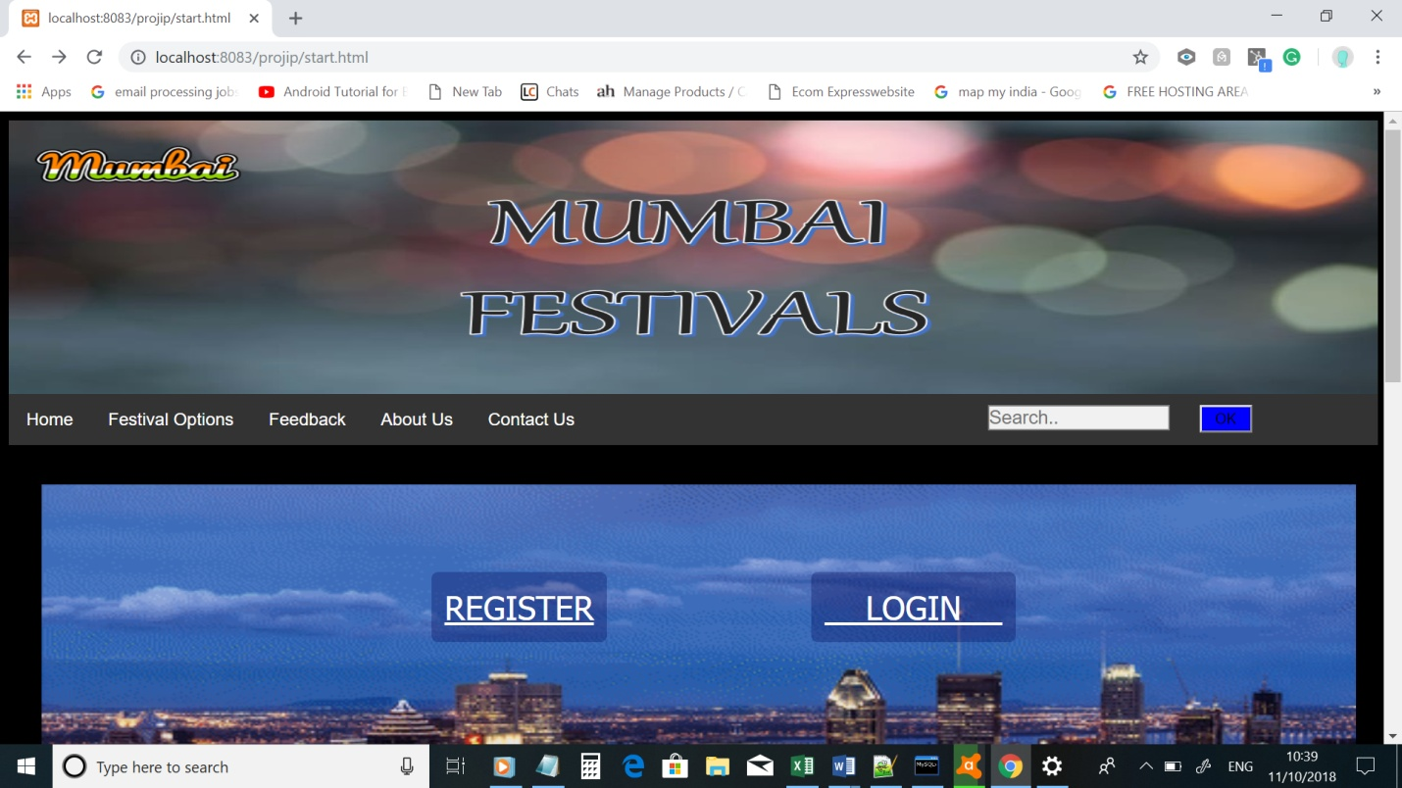
2. **Fig. 5.1: Homepage**

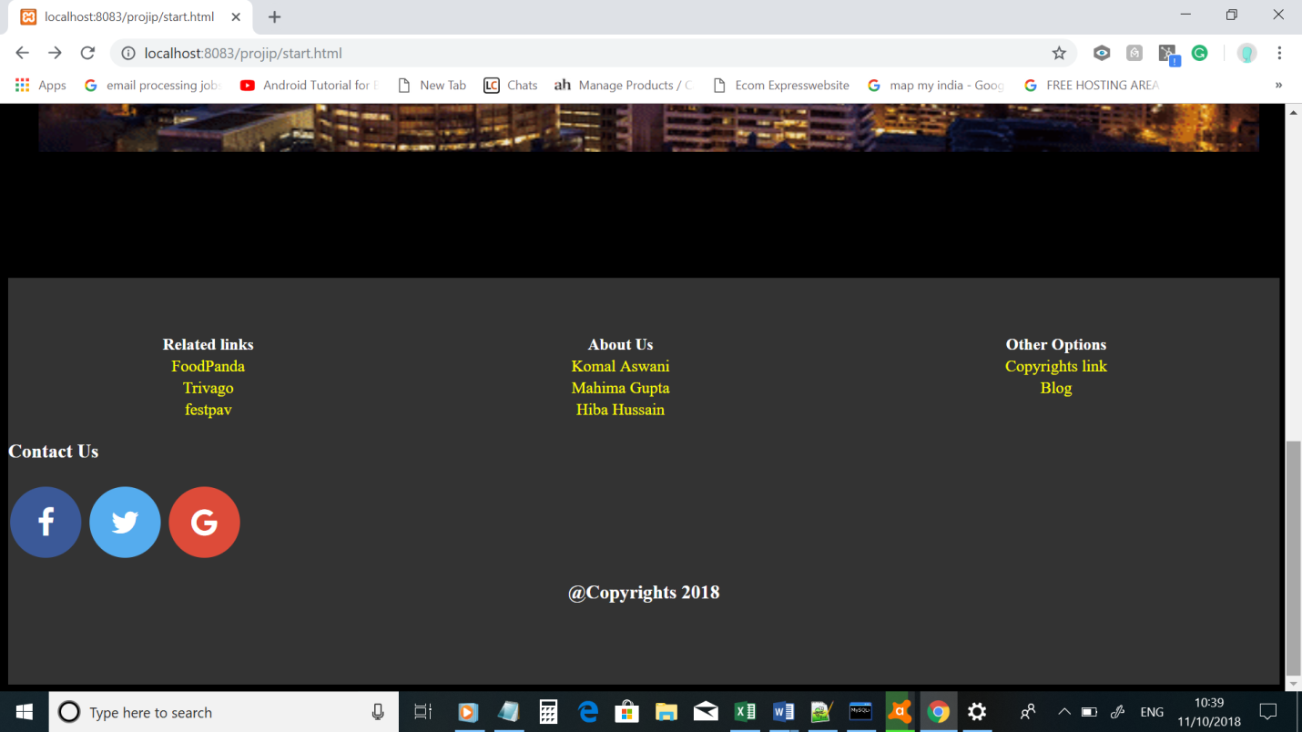

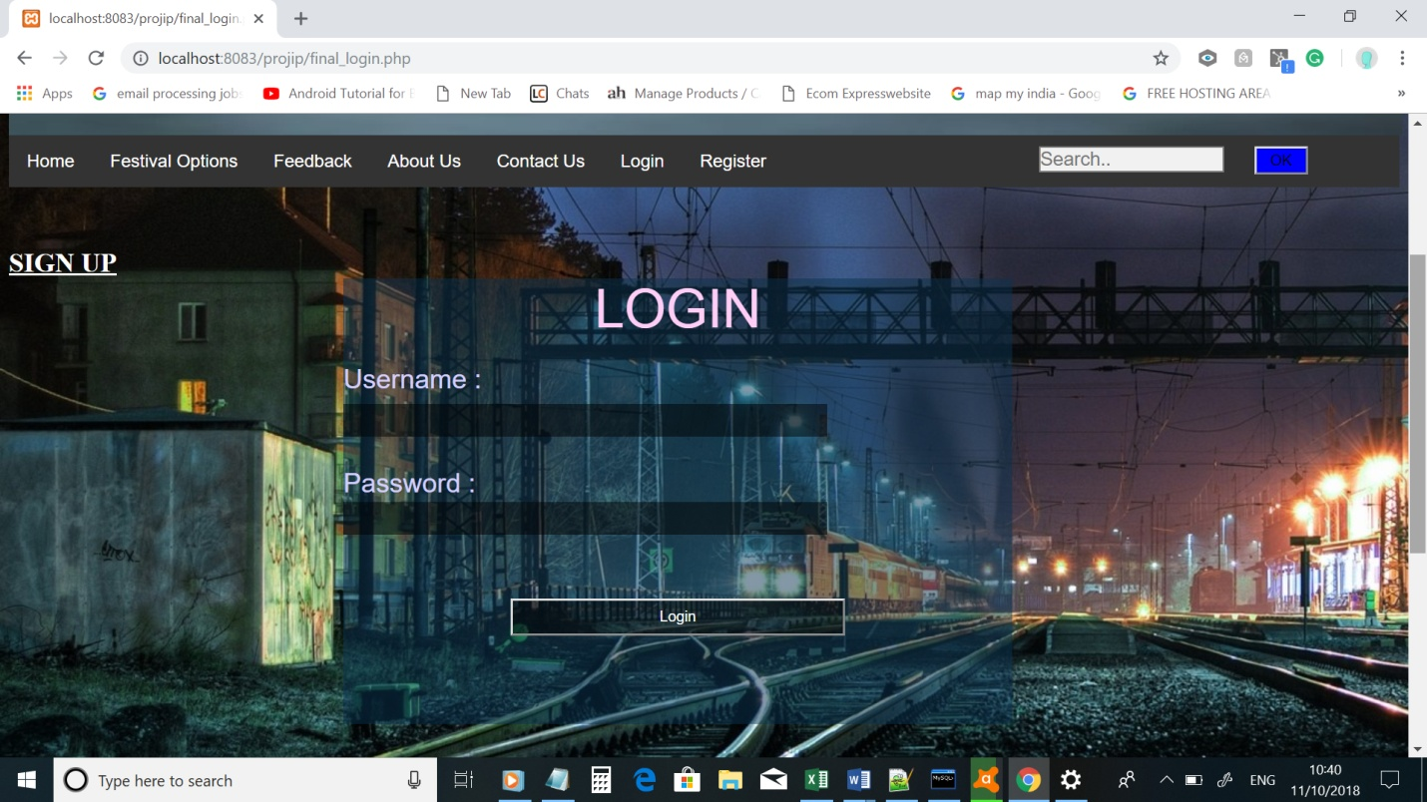

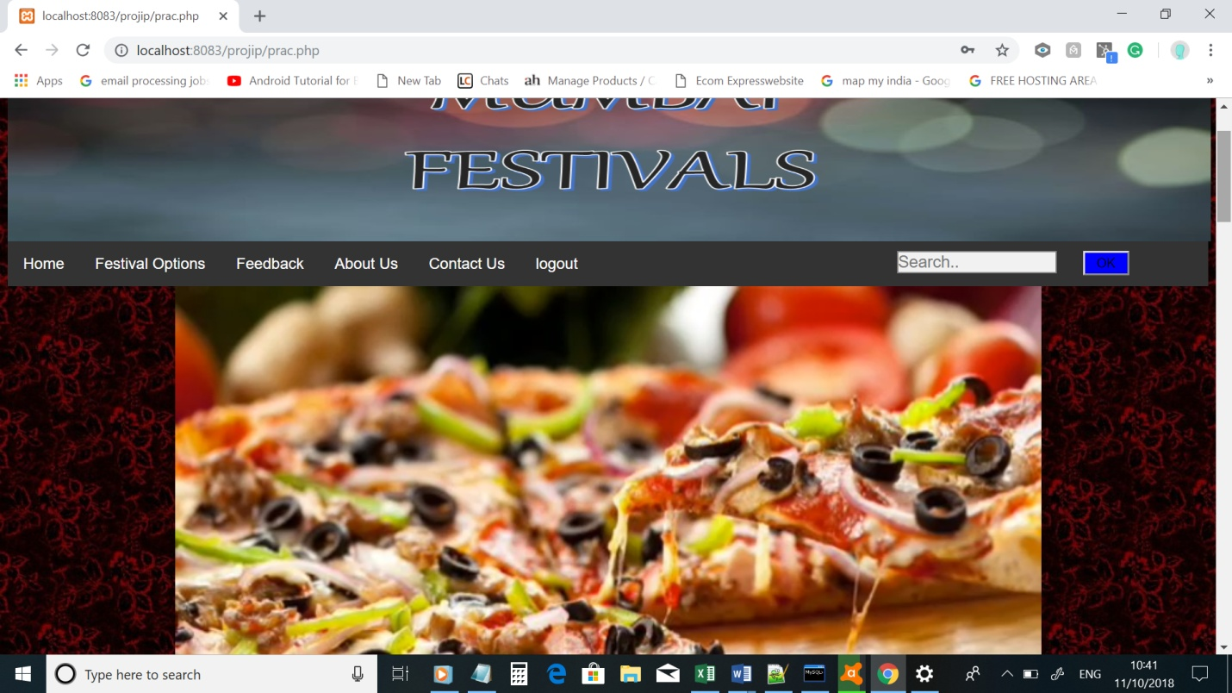

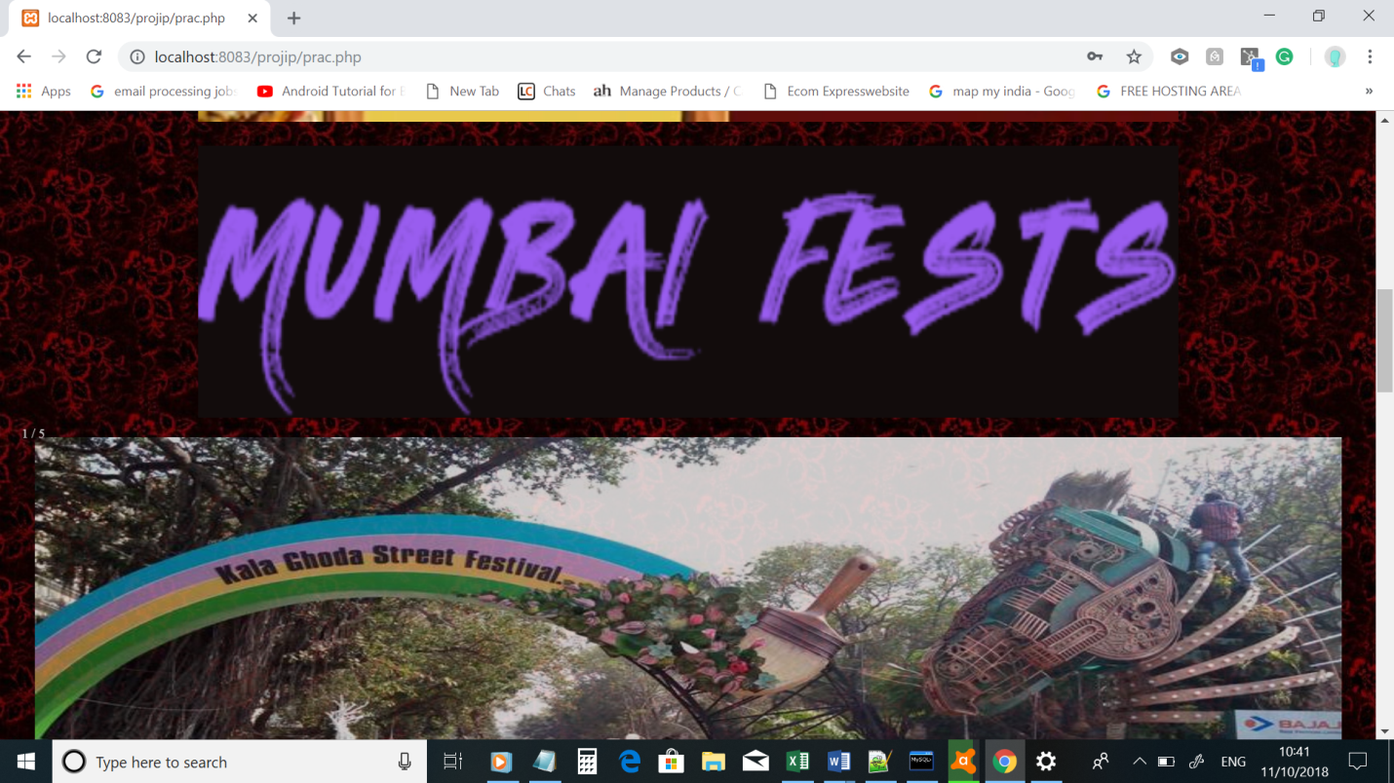

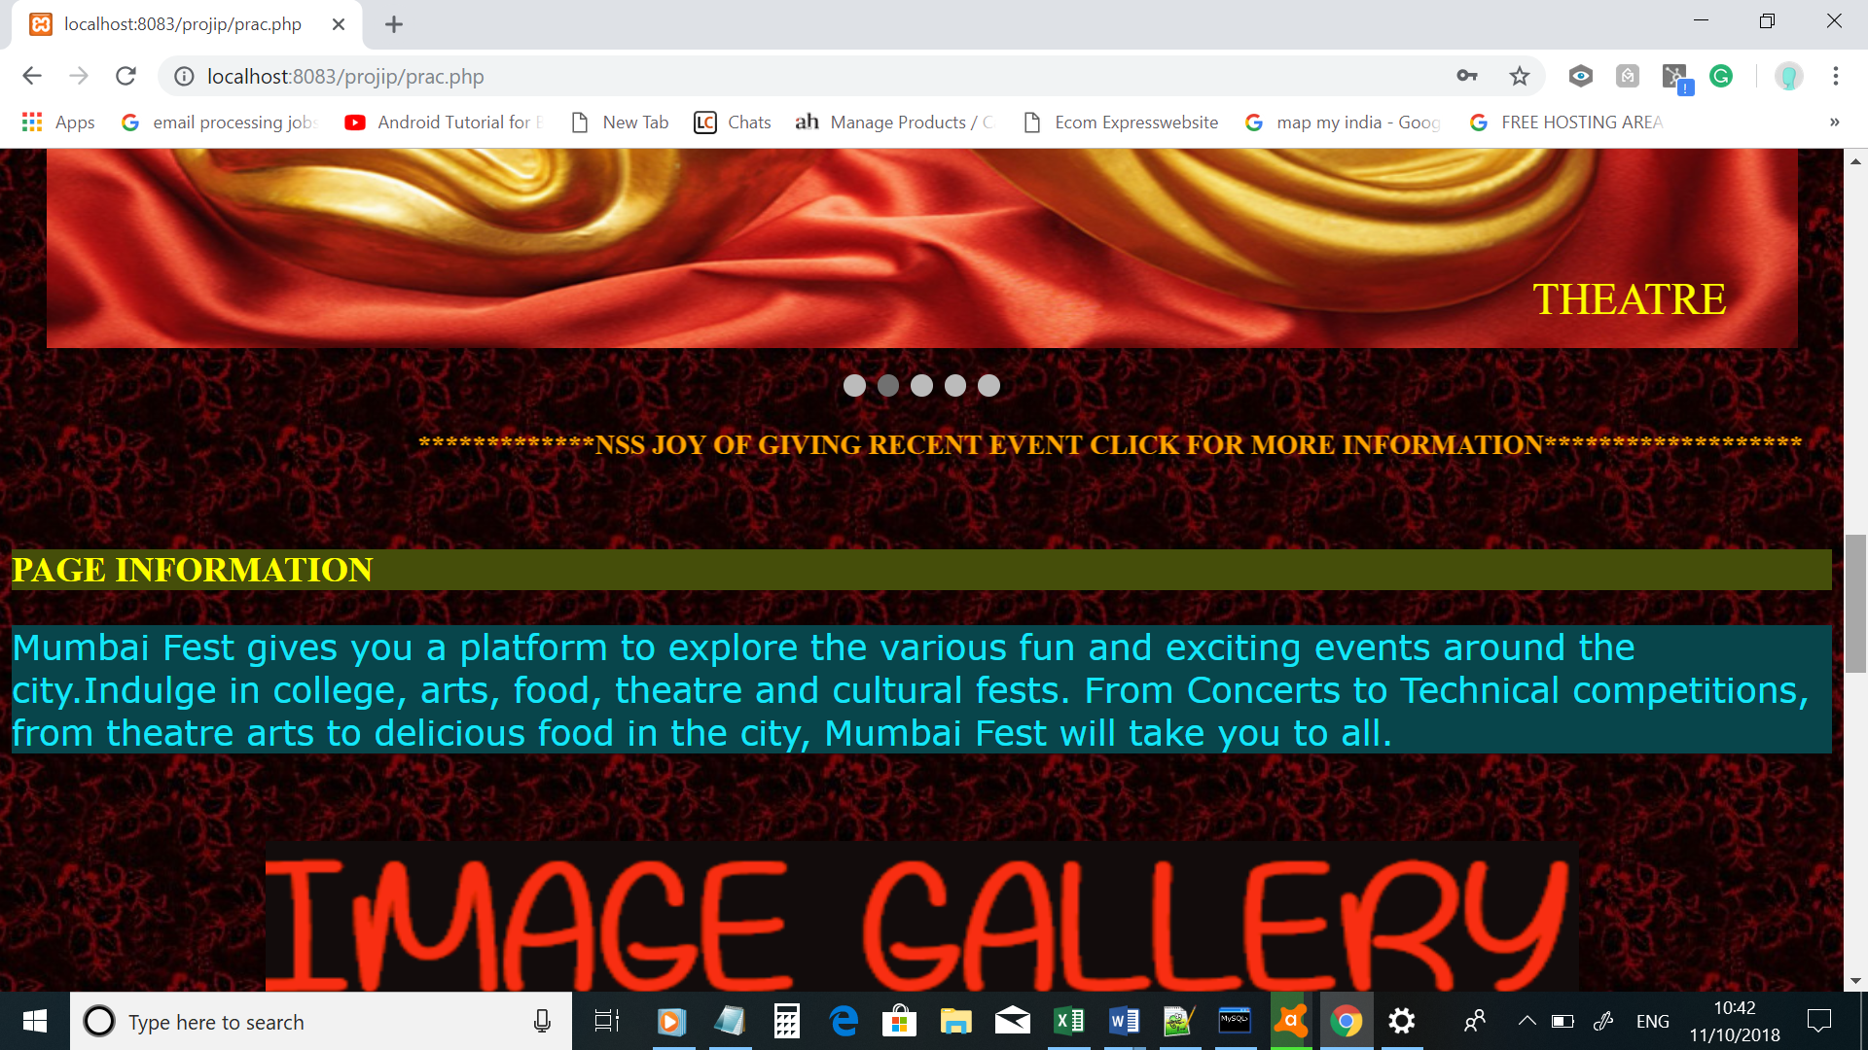

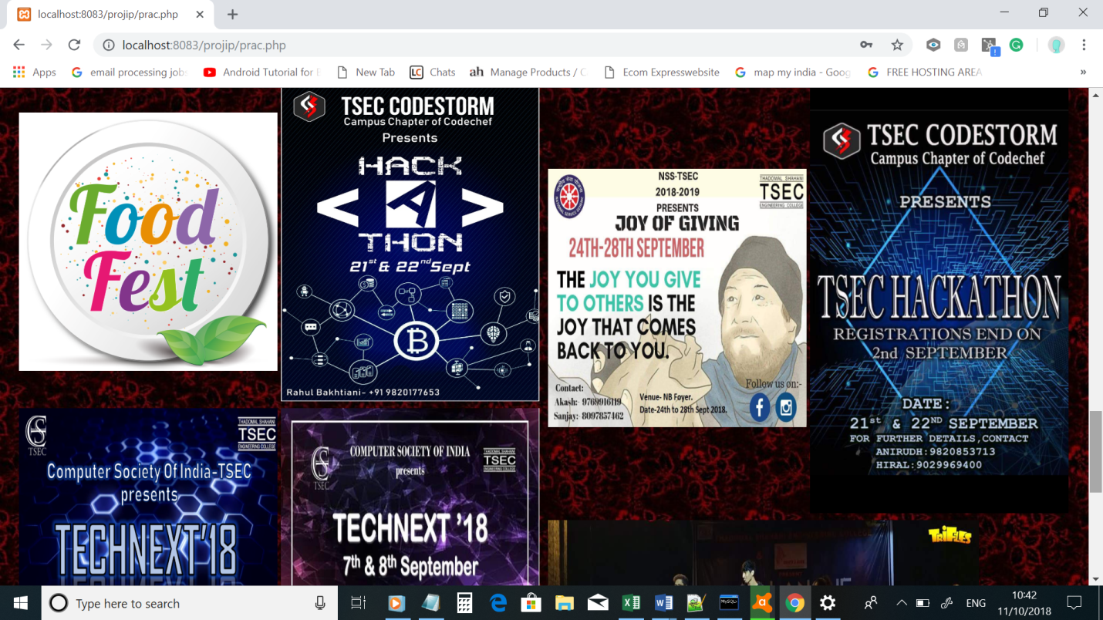

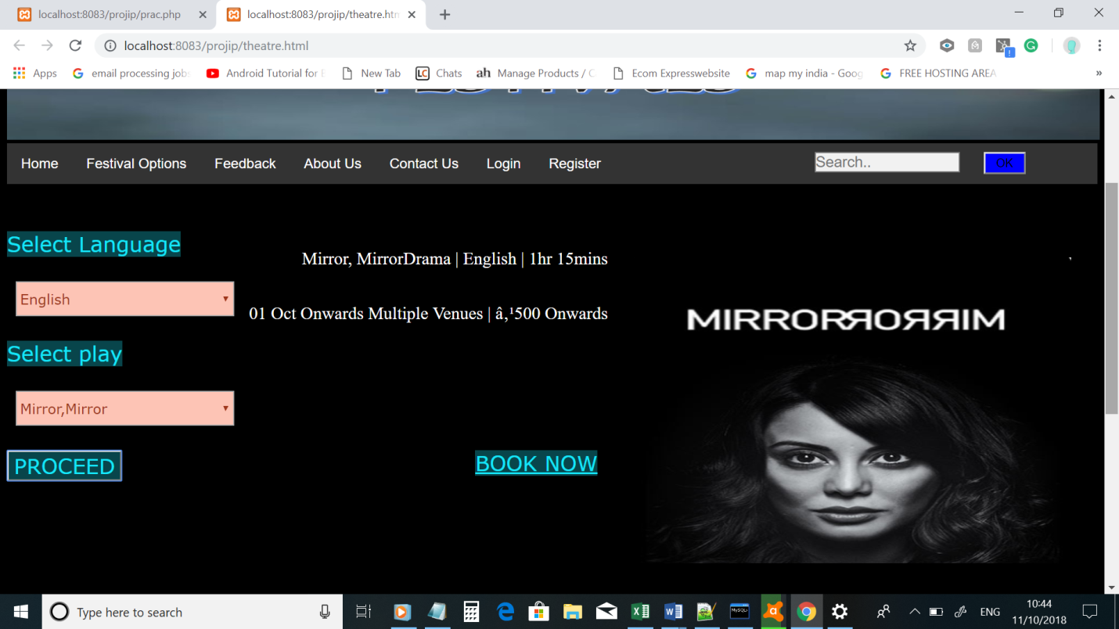

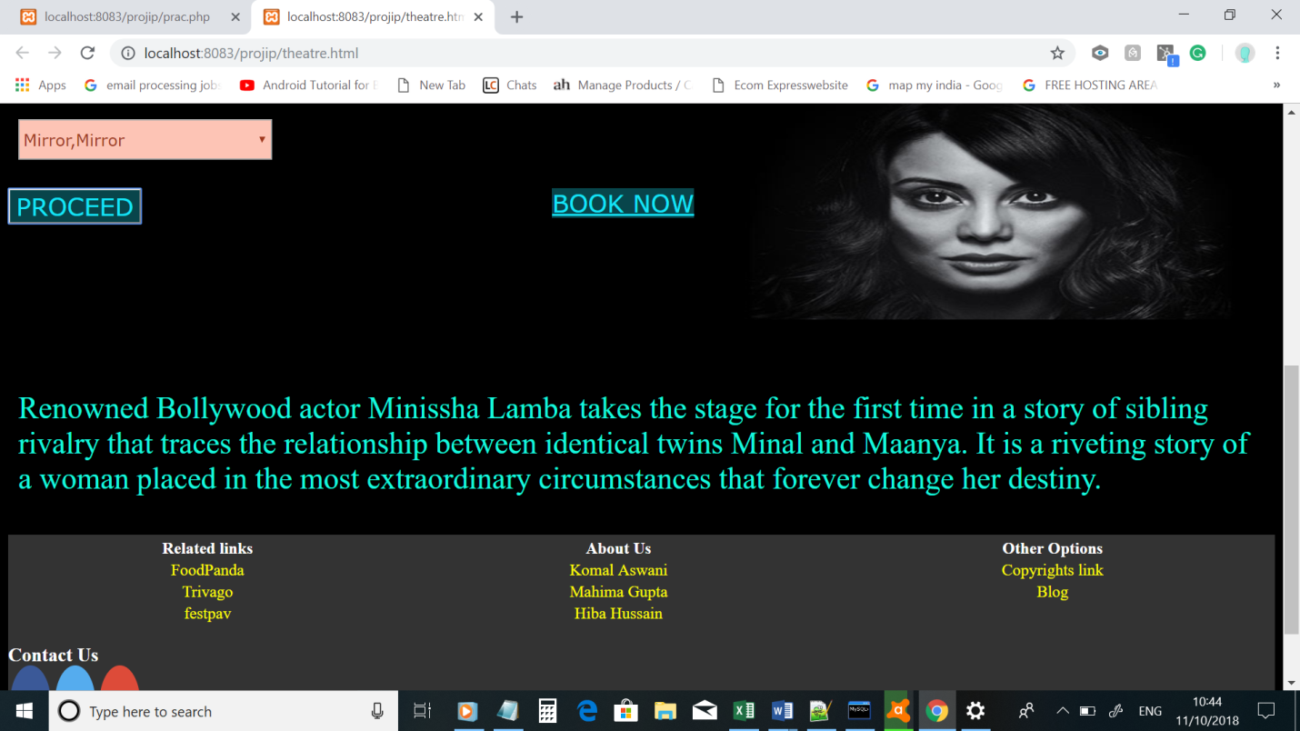

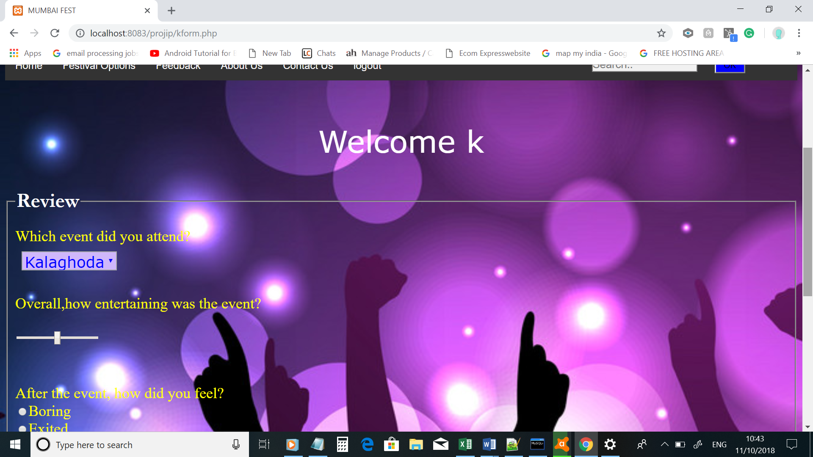

**References**

[1] www.w3schools.com

[2] www.eventshigh.com

[3] <http://php.net/manual/en/tutorial.forms.php>

[4]

**Acknowledgement**

We are highly appreciated to get an opportunity to build this project in our academics curriculum itself. We would like to thank IT Department for providing a platform where in we were able to showcase our skills to the best of our abilities.

This project would not have been possible without the guidance of our mentor, Mrs. Sanober Shaikh, who supported us and helped us during our project by letting us know the various methods to make our project complete with all the necessary requirements. This helped us to create our website as we dreamt and achieve our goal.

We would also like to extend our vote of thanks to the HOD of IT Department, Mrs. Madhuri Rao.